Selected Photographs

Volume 1

Michael Gogins

This book is for Mick.

This book and all images herein are copyright 2022 by Michael Gogins, all rights reserved. The contents of this book are licensed under the terms of the Creative Commons [Attribution-NonCommercial-NoDerivatives 4.0 International](ttps://creativecommons.org/licenses/by-nc-nd/4.0/legalcode) license.

In short, you may use, print, and copy this book or any of its contents for your own personal use, but you may not use this book or any of its contents as part of your own projects, or for commercial purposes.

If you wish to use this book or any of its contents for your own projects, or for commercial purposes, for example to re-publish or to exhibit in a gallery, please contact me directly.

# Introduction

This book contains my selection of pictures from a lifetime of taking photographs. I have never been a professional, but I was and am committed to the art of photography. I am a “street photographer” open to abstraction. I shoot what catches my eye and I prize beauty. When I take pictures of people, I often prefer they don't notice. My reason for doing photography is to see more clearly what God has created.

These pictures were variously taken with 35 mm film cameras, a variety of digital cameras, and smartphones. They were taken in my native state of Utah, other states including Washington, California, and New York, and countries around the world. I have tended to use the sharpest possible camera that is small enough to carry with me at all times. For some years now I have been using the Sony RX100 series. Increasingly, however, I am finding that my smartphone is a real camera.

The images are all in natural color. They are all shot as far as possible without image manipulation; in a few cases, I have leveled horizons or removed spots. I shoot in JPEG rather than RAW. Selected metadata from the photographs is printed. If the photograph is a digital scan of a 35 mm slide, the creation date is the date of that scan. Captions are incomplete and cryptic. Images are, to the best of my recollection where timestamps are lacking, in chronological order.

*All pictures are included in the full resolution with which they were taken or scanned*. Thus, you can zoom into any image to see more detail. Pictures copied out of this book will also be in full resolution. As the file size of this book would otherwise become unmanageable thanks to the use of uncompressed images, it has been split into volumes of no more than about 500 megabytes each. Even so, the files are huge.

I invite the reader to copy pictures out of this book for printing and viewing, but not for commercial use or re-publication.

If I take more pictures that I think are good enough to be in this book, I will add new volumes.

Table of Contents

Introduction 3

Photographs 4

c-2013-03-12_12-07-24.jpg 4

Mick,_Wendy,_Jane,_Michael_Xmas.jpg 8

# Photographs

## c-2013-03-12_12-07-24.jpg

This is a scan of the first picture I took that I actually liked, a 35 mm slide. It was in 1968 in the back yard of my father's girlfriend Doreen's house in Taylorsville, Utah, just after sunset. I believe this was Christmas Day.

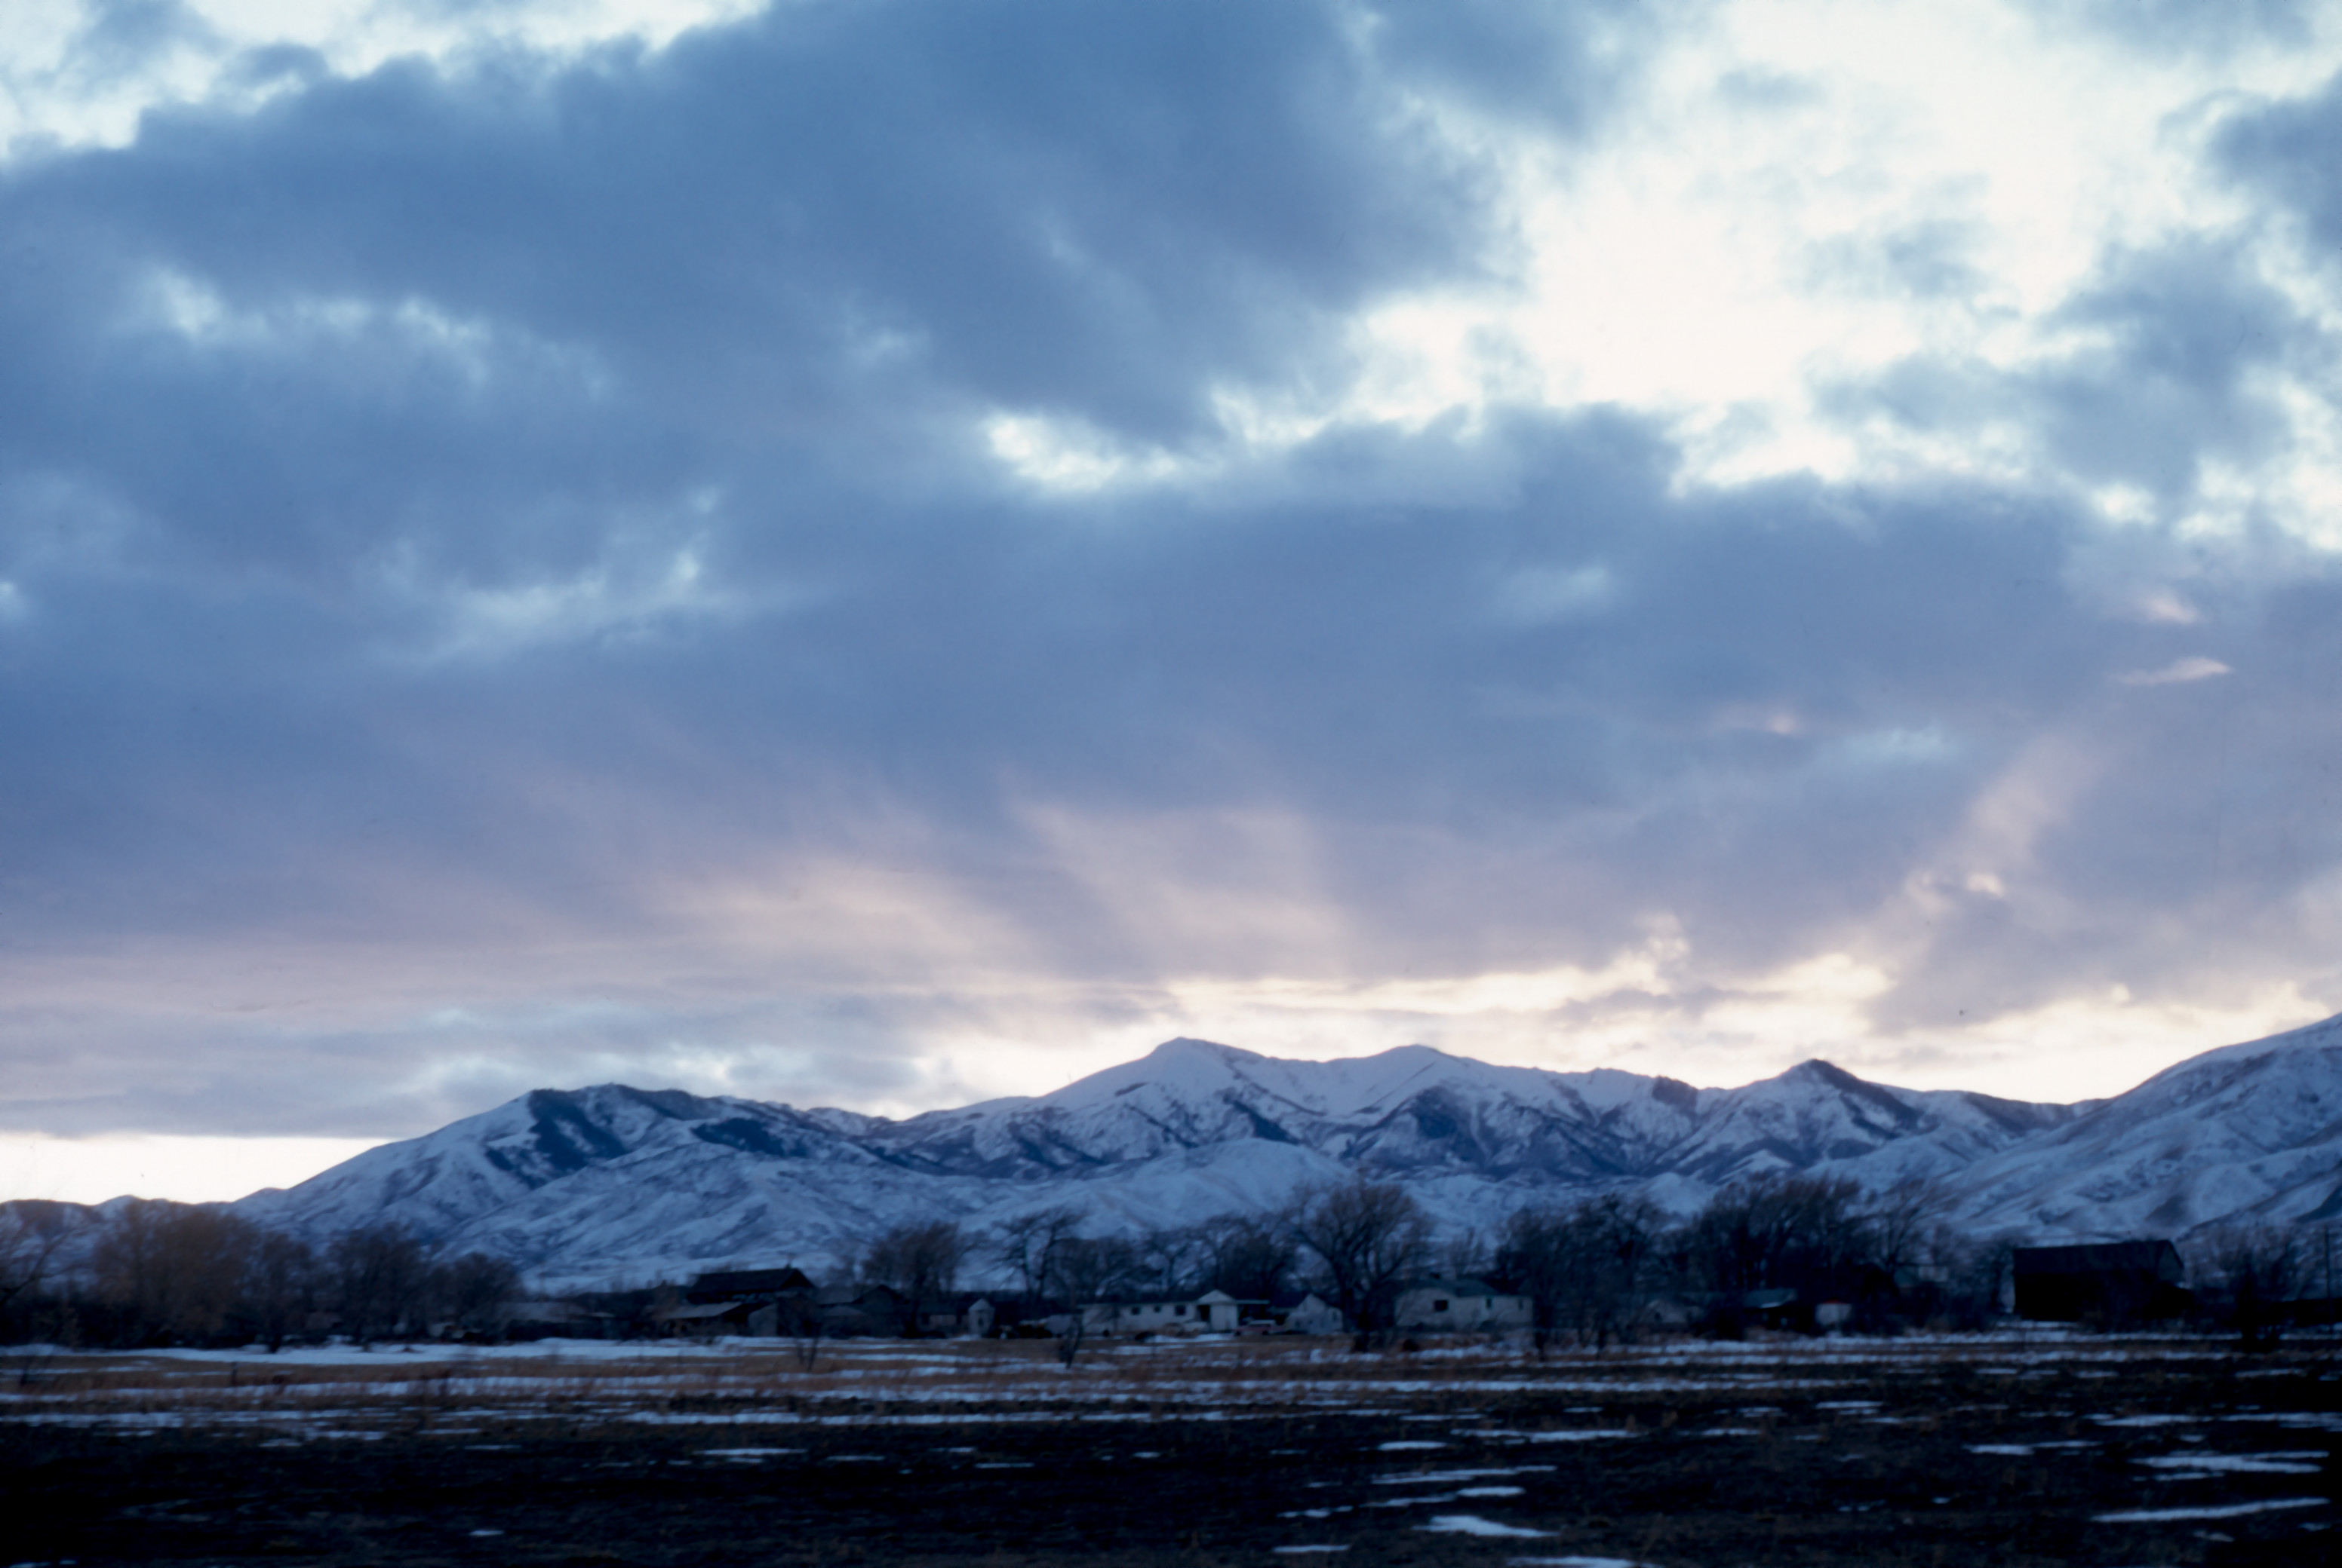

## Mick,_Wendy,_Jane,_Michael_Xmas.jpg

Scan of a slide of my grandfather Milton (Mick) Swensen, my sister Wendy, my grandmother Jane, and myself, Murray, Utah, Christmas or New Years 1968 I think.

